New Tofino™ VPN module secures remote SCADA communication
Easy to deploy modules provide reliable security over untrusted networks
July 28th, 2009 – Lantzville, British Columbia, Canada.

Byres Security Inc. and MTL Instruments, a division of Cooper Crouse-Hinds, are announcing the introduction of the Tofino™ Virtual Private Network (VPN) product line as part of the Tofino™ Industrial Security Solution, extending cyber security beyond plant walls. The Tofino VPN Server LSM, the Tofino VPN Client LSM, and the Tofino VPN Client License are designed specifically to be simple to use and to securely connect facilities and people together over untrusted networks, such as the Internet. The products will be available as of July 31, 2009.
Security for the Tofino VPN is provided by Secure Sockets Layer (SSL) – a proven technology that is the foundation of all web ecommerce and is widely considered to be less complex to configure than other VPN technologies. Deployment is completed centrally using the Tofino Central Management Platform (CMP), and does not require any changes to existing control system network design or addressing. Handling of security components occurs behind the scenes, making setup a simple drag-n-drop process. Like other Tofino products, the Tofino VPN modules can also be operated in “test” mode before they are activated. All of these features make the setup of the Tofino VPN easy, ensuring that neither industrial security nor industrial reliability are compromised by complex configuration errors.
In addition to providing secure tunnels for communication, the Tofino VPN solution integrates seamlessly with the Tofino Firewall LSM and the Tofino Modbus TCP Enforcer LSM. This close integration makes certain that only “permitted” messages are distributed, and not potentially dangerous transmissions such as a virus originating from a remote PC, or a user sending inappropriate programming commands.

The Tofino VPN is unique, having an integrated SCADA-capable firewall that provides a high degree of granularity in setting access rules. For example, it allows the designation of specific computers (such as remote Human Machine Interface PCs) to have read-only access to PLCs for operational diagnostics, whereas a limited set of maintenance laptops can have remote programming access to PLCs.
Eric Byres, a leading global industrial security expert and the CTO of Byres Security Inc., points out, “Our approach with the Tofino Industrial Security Solution is to deliver a system that is designed with the rugged environment, staff skills and needs of industry in mind, and that can be installed without plant downtime. Unlike IT VPN solutions, the Tofino VPN products are readily configured and managed by controls engineers, they can be tested and implemented without risk to industrial processes, they are part of an industrially hardened system and they support legacy automation devices and protocols.”
Uses of the Tofino VPN include:
- Monitoring and controlling remote sites from a central location
- Providing secure access to control systems for remote personnel
- Securing communications between critical controllers
- Allowing legacy non-IP control traffic to travel over IP networks

The Tofino VPN LSMs create secure tunnels for communications between:
- Tofino Security Appliances (Tofino SA’s)
- Tofino SA’s and PC
- Tofino SA’s and supported third-party devices
To learn more about the Tofino VPN solution and the complete Tofino Industrial Security Solution, please visit www.tofinosecurity.com.
Tofino™ VPN Diagrams
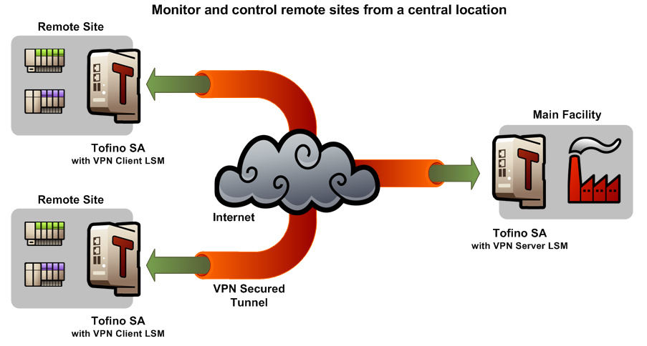

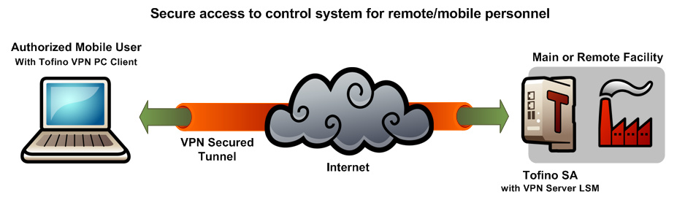

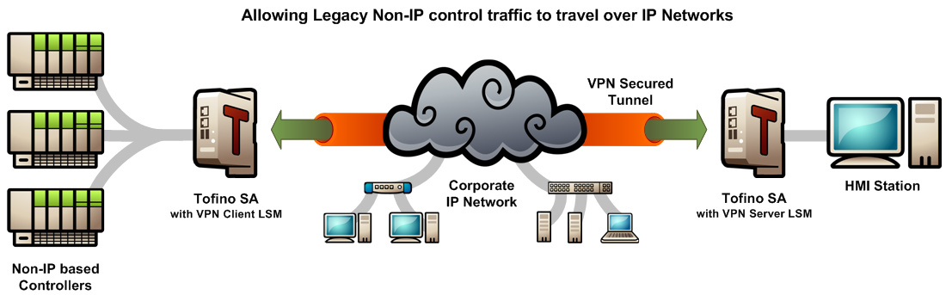
About Byres Security
Byres Security Inc. is a world leader in the field of industrial cyber security for critical infrastructure companies, including the oil and gas, power, chemical, and manufacturing sectors.
Its flagship product, the Tofino™ Industrial Security Solution, is a unique hardware and software security system that provides Zone Level Security™ (ZLS™) – tailored, protection for zones of control devices. Tofino is simple to implement, does not require downtime, and takes care of security while focus is maintained on keeping processes running safely and efficiently.
About MTL Instruments
MTL Instruments, a division of Cooper Crouse-Hinds, is a world leader in the development and supply of electronic instrumentation and protection equipment for the process control and telecommunications industries. Many of the world's most critical processes are monitored, controlled or protected by MTL equipment and the Group is distinguished by the quality and reliability of its products, its global network of sales-and-support centres and its acknowledged position as a thought-leader in this high technology marketplace. With 36 dedicated sales centres in 13 countries and a further 137 MTL representatives in 64 countries, MTL's expertise in Intrinsic Safety, Industrial Networks, Surge Protection and Operator Displays/HMI is unsurpassed.
MTL Instruments manufactures the Tofino Security Appliance and sells and supports the Tofino Industrial Security Solution worldwide to the oil and gas, petrochemical and pharmaceutical industries.

For further information please contact:

Joann Byres | Philip Nunn
CEO | Product Manager, Industrial Networks
Byres Security Inc | MTL Instruments
joann@byressecurity.com | pnunn@mtl-inst.com
+1 250 390 1333 | +44 (0)7808 052957
www.tofinosecurity.com | www.mtl-inst.com
~ ENDS ~

Loadable Security Modules

